Di VirtualBox
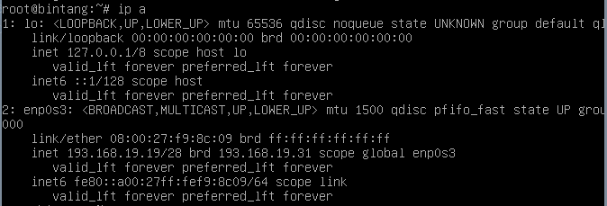

Masuk cmd
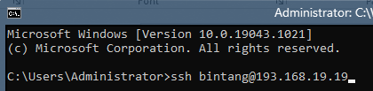
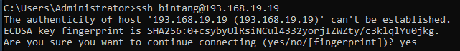
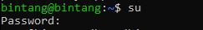

cat <<EOF > /etc/apt/sources.list
deb http://deb.debian.org/debian bullseye main contrib non-free
deb-src http://deb.debian.org/debian bullseye main contrib non-free

deb http://deb.debian.org/debian-security/ bullseye-security main contrib non-free
deb-src http://deb.debian.org/debian-security/ bullseye-security main contrib non-free

deb http://deb.debian.org/debian bullseye-updates main contrib non-free
deb-src http://deb.debian.org/debian bullseye-updates main contrib non-free
EOF

# Update paket sistem
apt update && apt upgrade -y

apt install bind9 dnsutils -y

cd /etc/bind

# Membuat salinan file konfigurasi
cp db.127 db.reverse
cp db.local db.forward

# Konfigurasi Forward Zone
cat <<EOF > /etc/bind/db.forward
; BIND data file for bintang.local
\$TTL 604800
@ IN SOA bintang.local. root.bintang.local. (
2 ; Serial
604800 ; Refresh
86400 ; Retry
2419200 ; Expire
604800 ) ; Negative Cache TTL
;
@ IN NS bintang.local.
@ IN A 193.168.19.19
www IN A 193.168.19.19
EOF

# Konfigurasi Reverse Zone
cat <<EOF > /etc/bind/db.reverse
; BIND reverse data file for bintang.local
\$TTL 604800
@ IN SOA bintang.local. root.bintang.local. (
1 ; Serial
604800 ; Refresh
86400 ; Retry
2419200 ; Expire
604800 ) ; Negative Cache TTL
;
@ IN NS bintang.local.
19 IN PTR bintang.local.
EOF

# Mendaftarkan Zone
cat <<EOF >> /etc/bind/named.conf.default-zones

zone "bintang.local" {
type master;
file "/etc/bind/db.forward";
};

zone "19.168.193.in-addr.arpa" {
type master;
file "/etc/bind/db.reverse";
};
EOF

# Set DNS Resolver
echo "nameserver 193.168.19.19" > /etc/resolv.conf

# Restart Service
systemctl restart bind9

# Verifikasi
echo "--- Testing DNS ---"
nslookup bintang.local
nslookup www.bintang.local

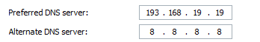

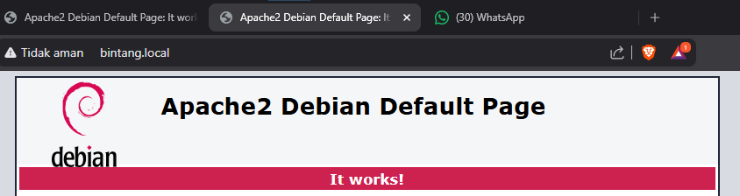

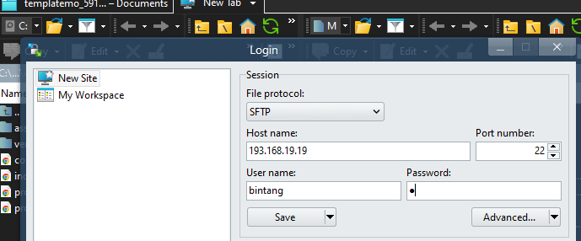

Hapus index.html yang lama & Ganti index.html yang baru

